|  |
| --- |
| **LAB 4** |
| SOAP AND RESTFUL SERVICES |
|  |
| This assignment deals with the creation of SOAP and RESTFUL Services along with the mobile web client application and making access through cloud instance. |
|  |
| **Karthik Repala** |
| **9/23/2013** |
|  |

**SOAP WEB SERVICES**

Creating a Web Service Application-

Go to File-New Project

Right Click on the project and click on Add new Item and Select the Web Service Application.

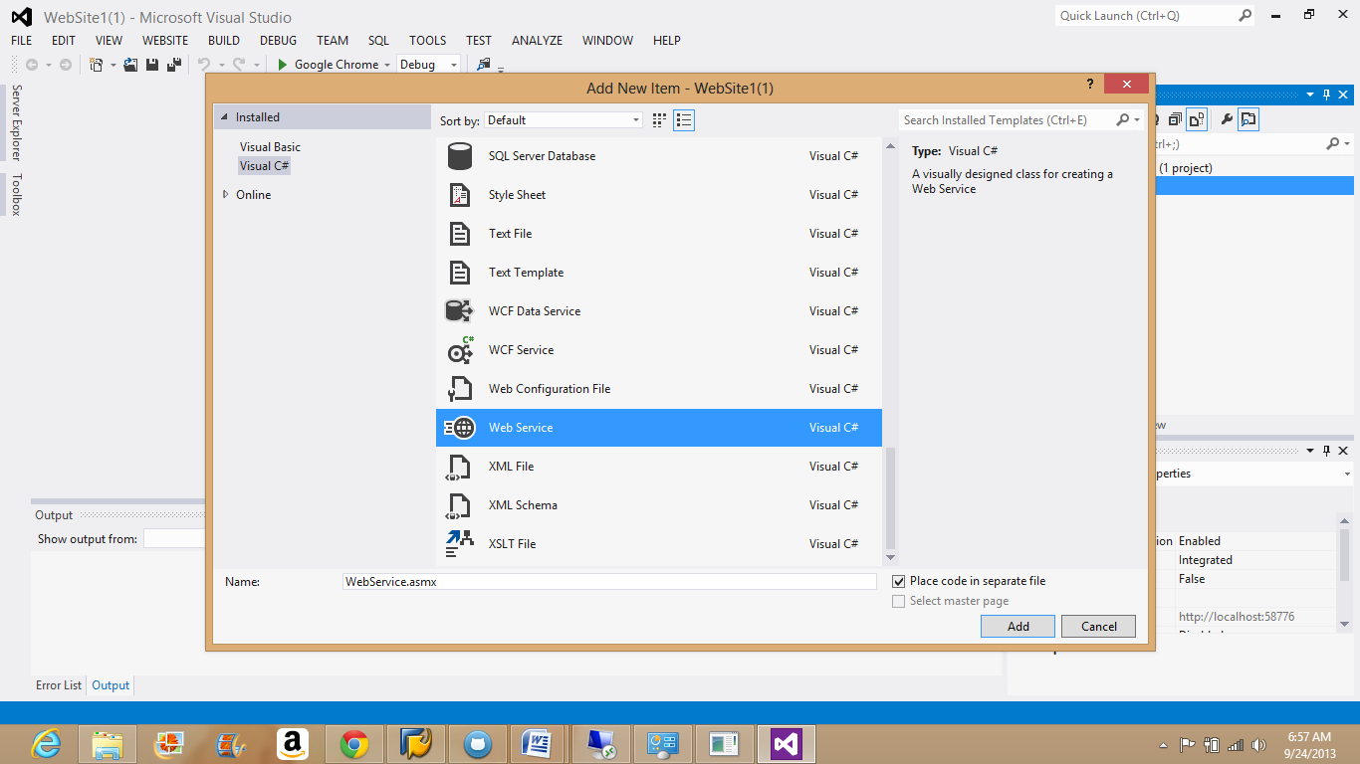

Write the required code in the editor shown below.

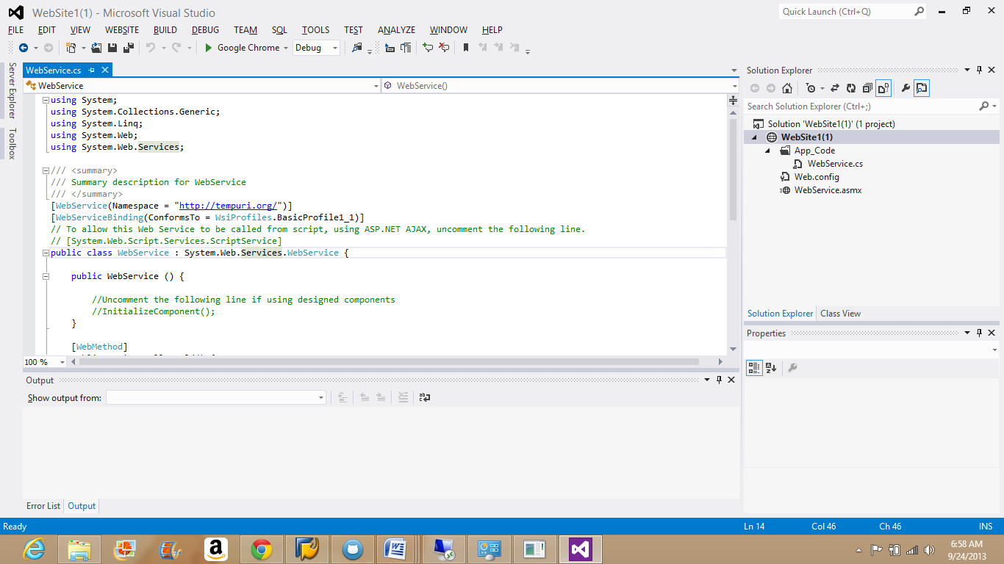

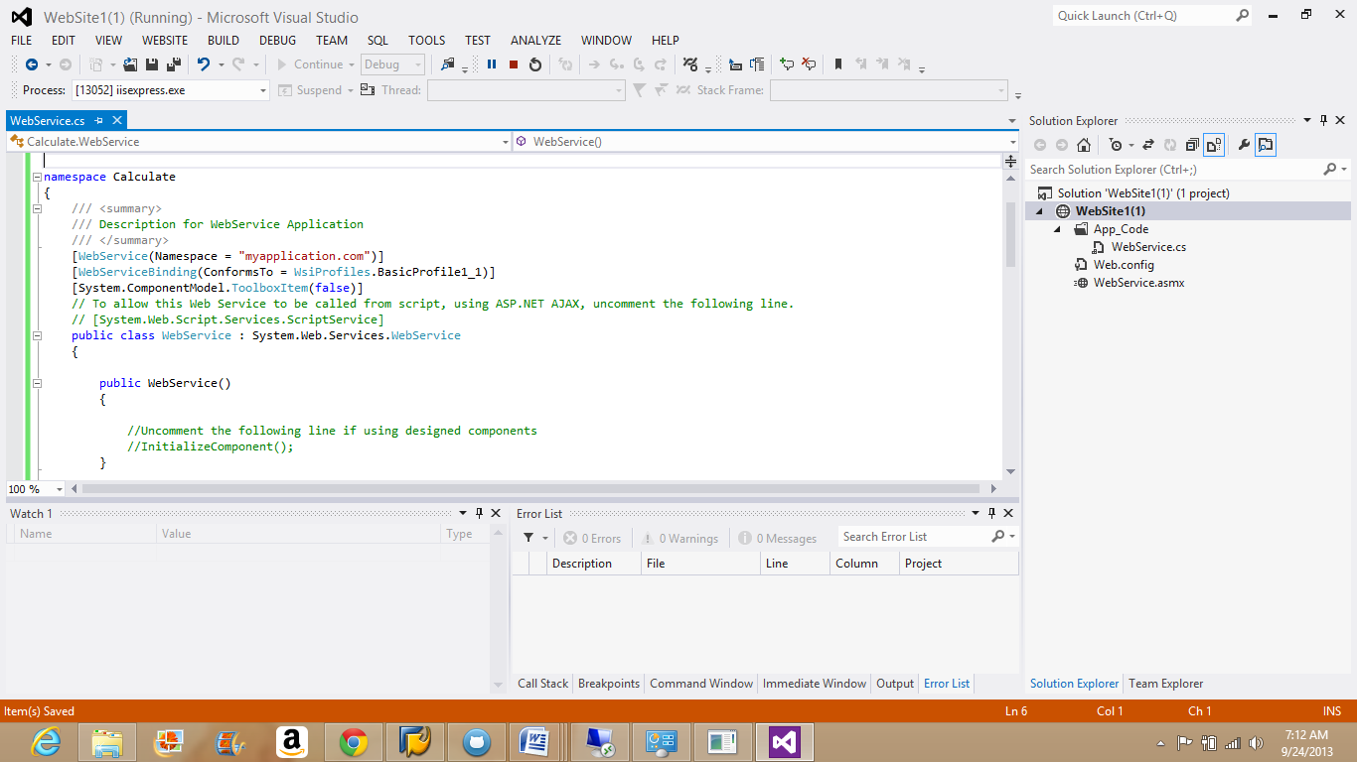

Build the code after finished with coding.

Go to Menu Build-Build Solution.

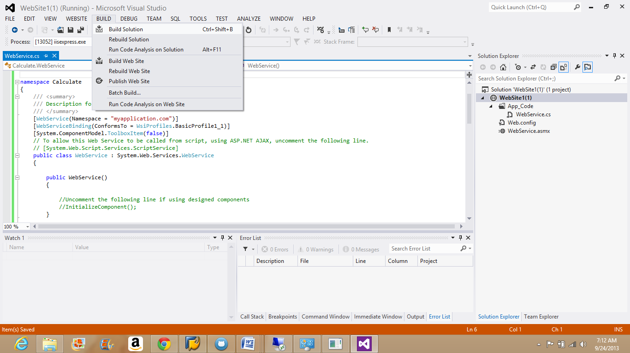

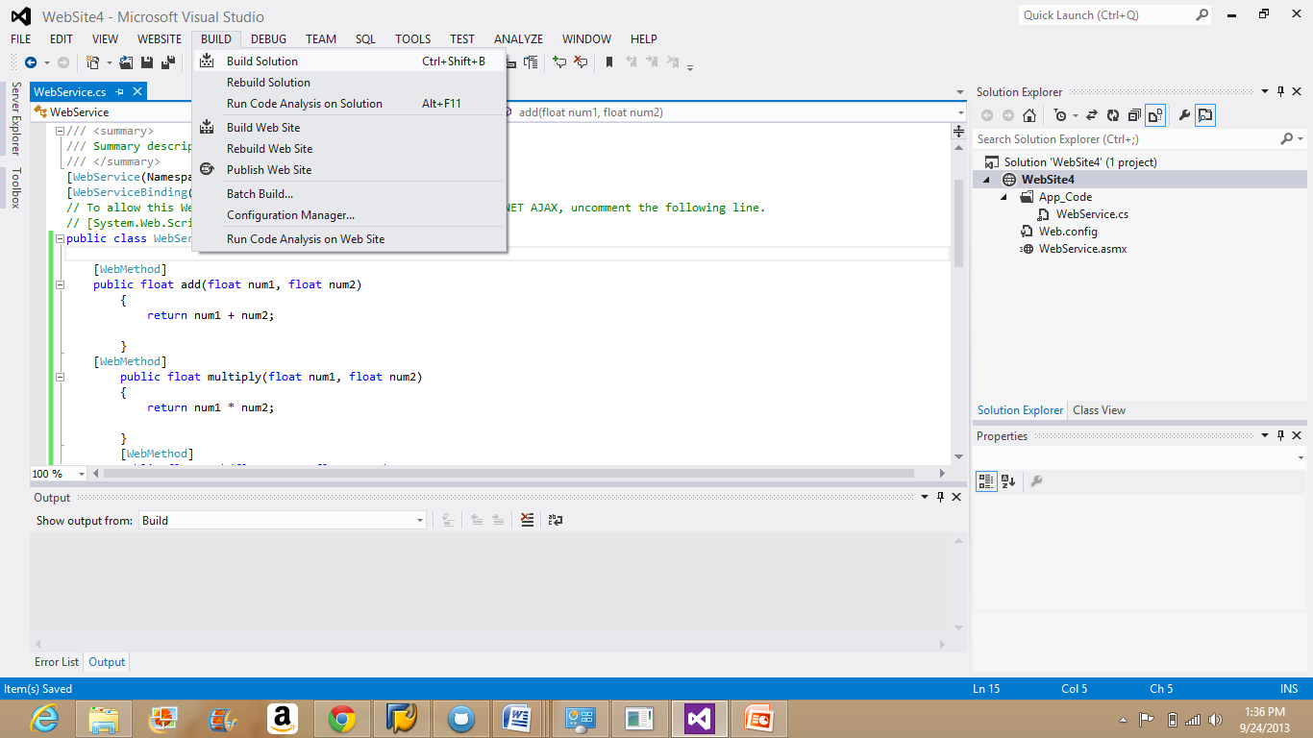

The code without errors gets build up and will be shown in the Output window, the one present below to the editor.

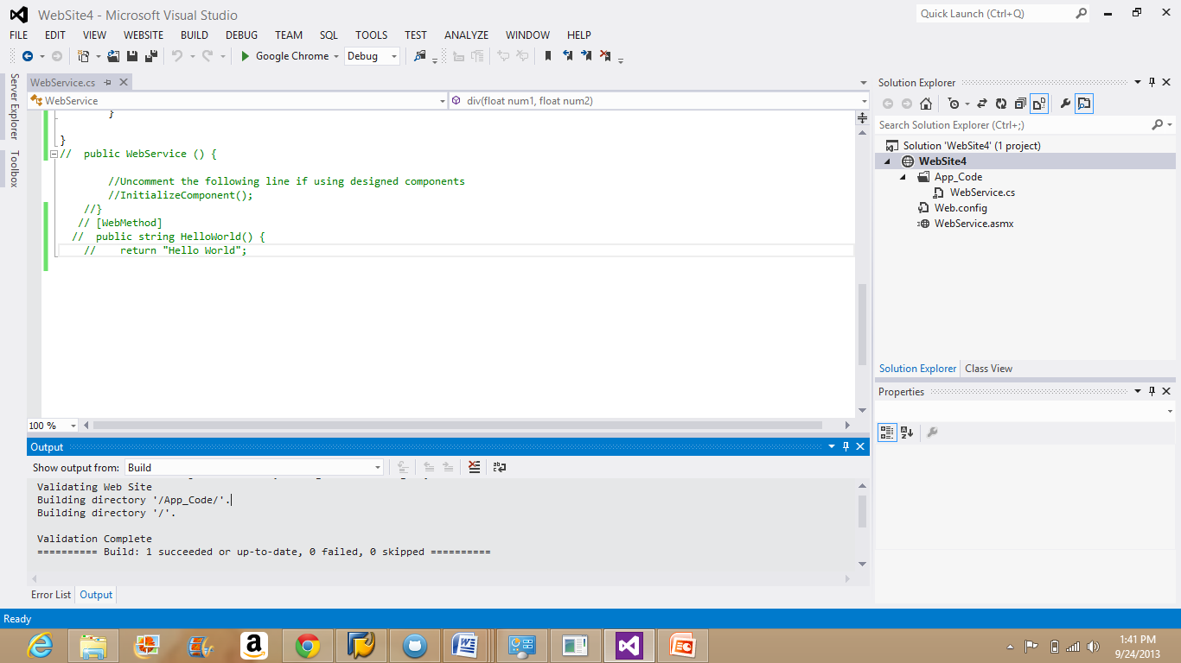

Once code is build, start the code without debugging.

Go to Menu Debug-Start without Debugging.

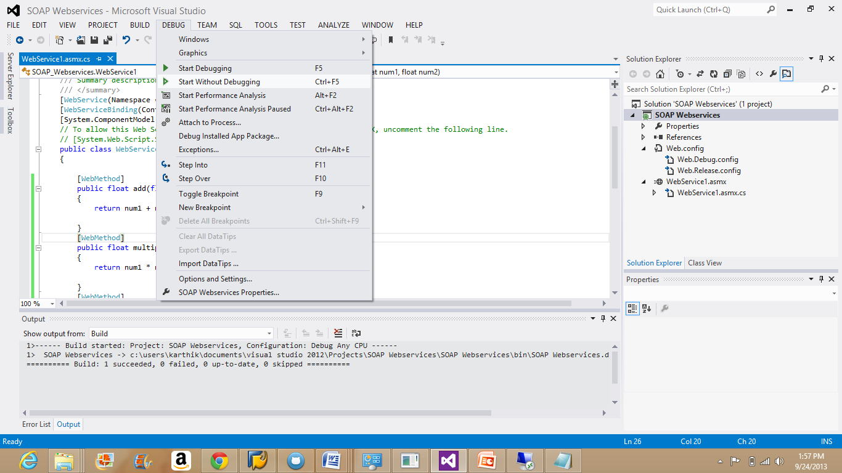

Right Click on the Web Service and choose open with browser option.

The following window gets displayed.

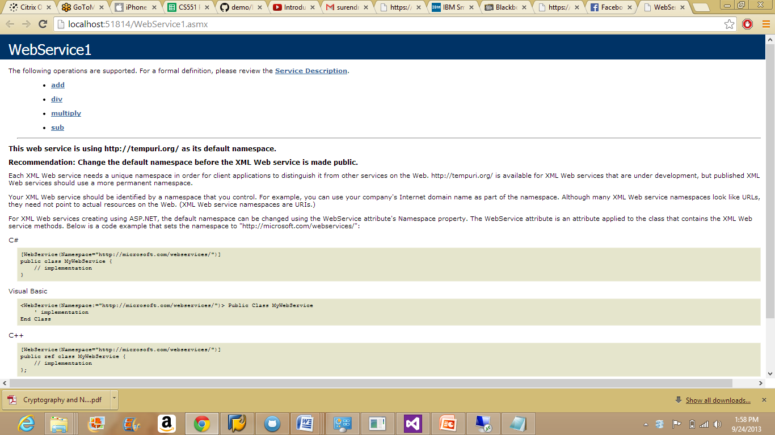

The below are the outputs of the basic arithmetic operations invoking and their results.

**Addition:**

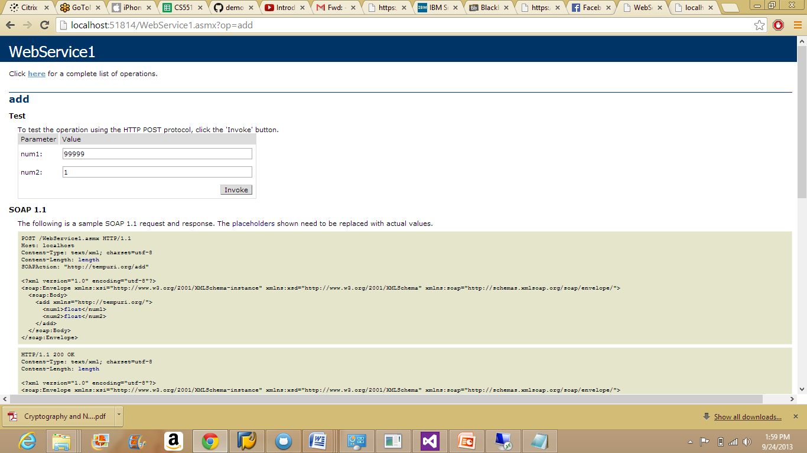

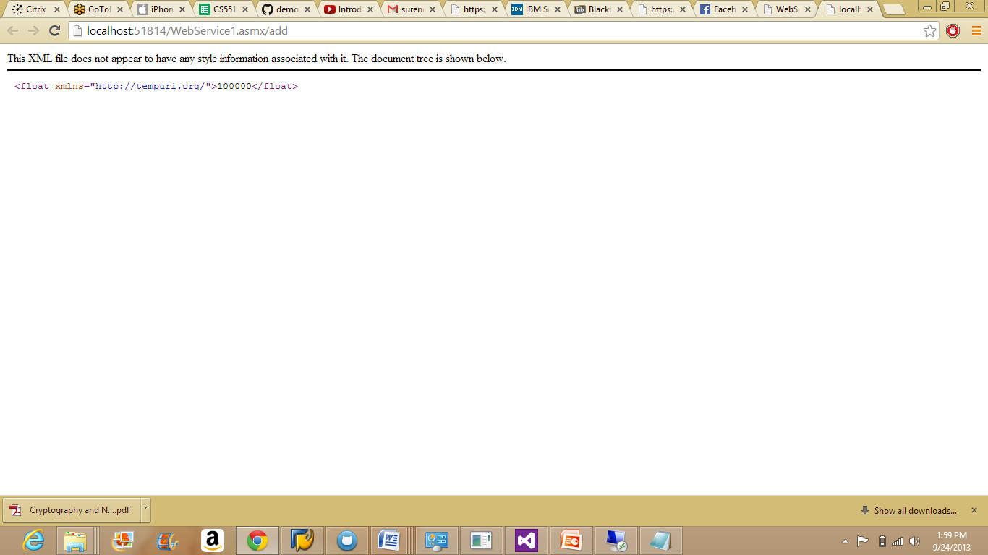

**Division:**

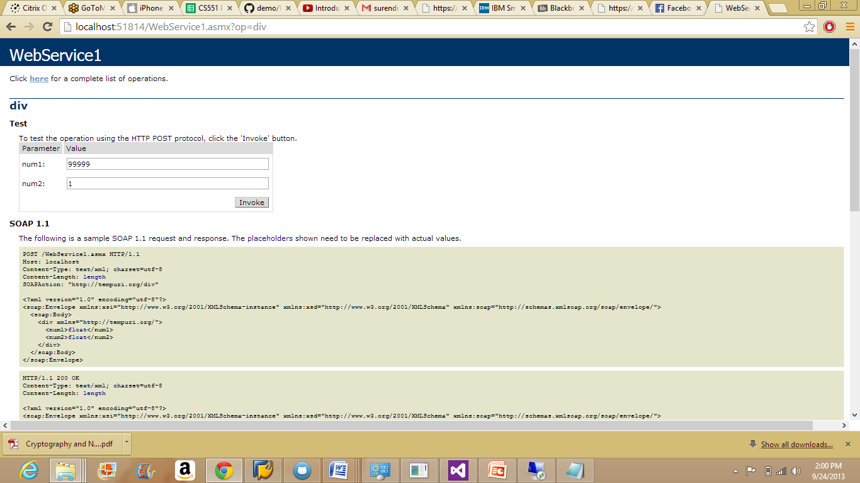

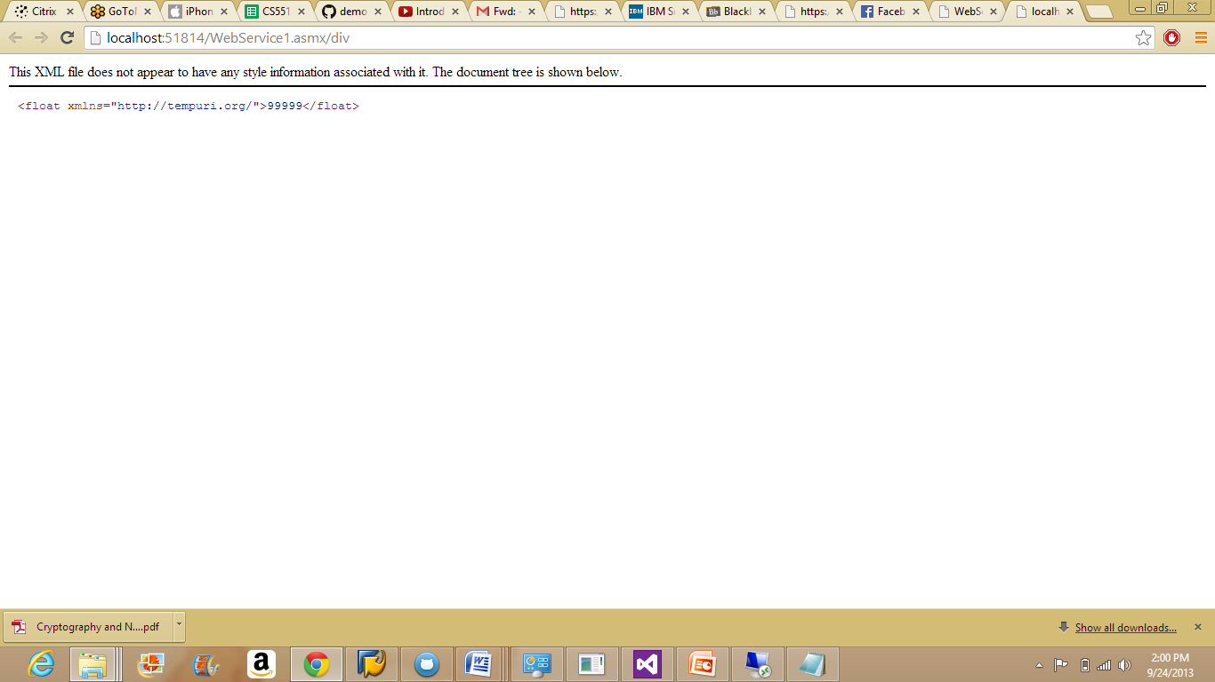

**Multiplication:**

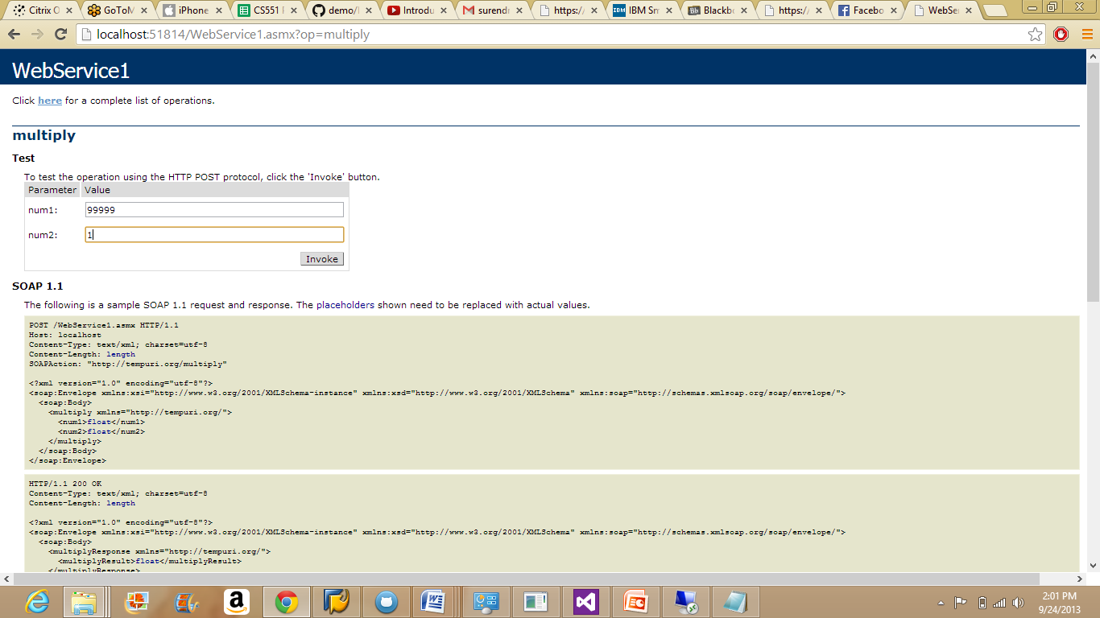

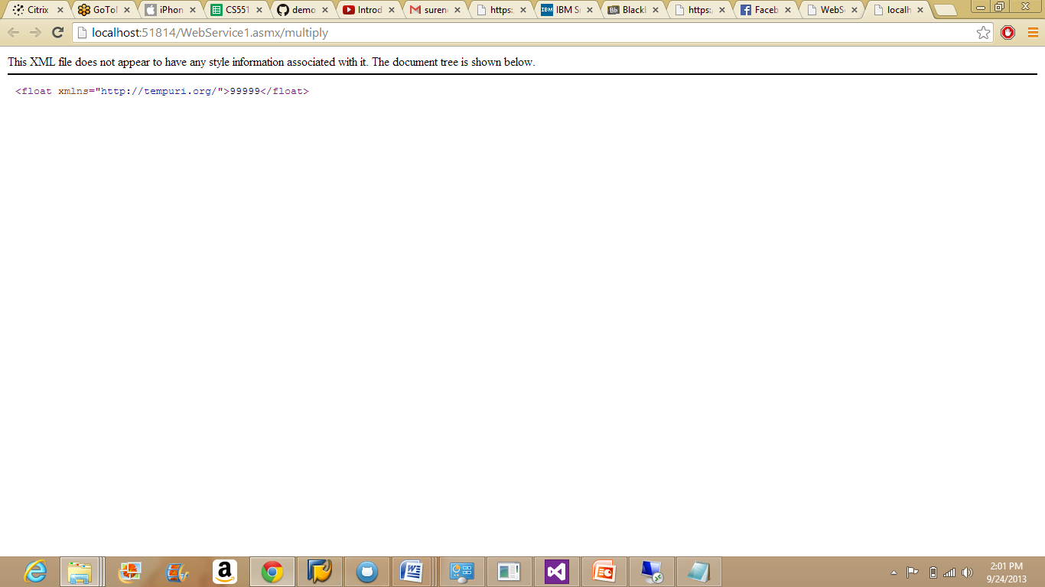

**Subtraction:**

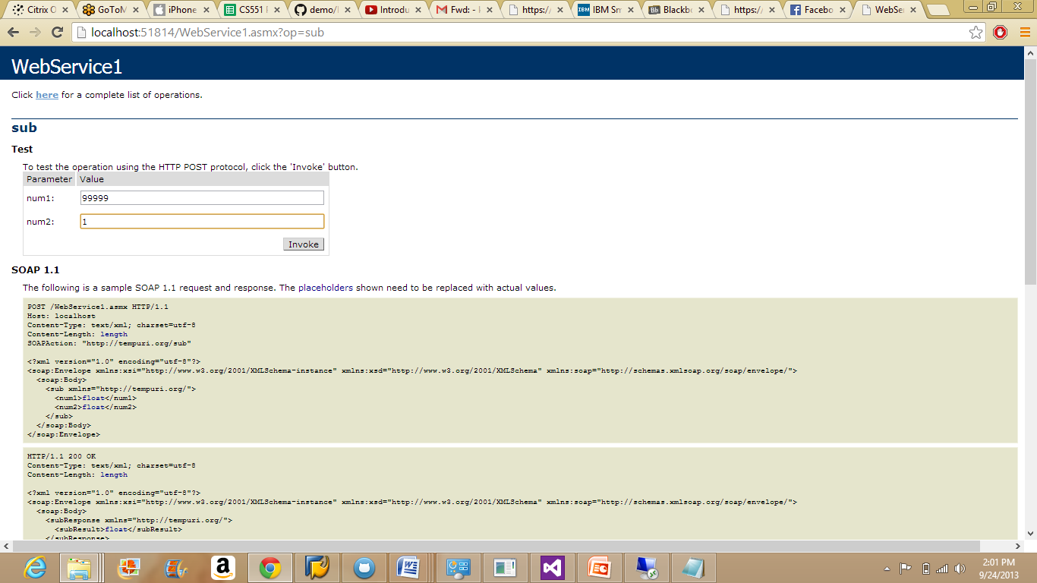

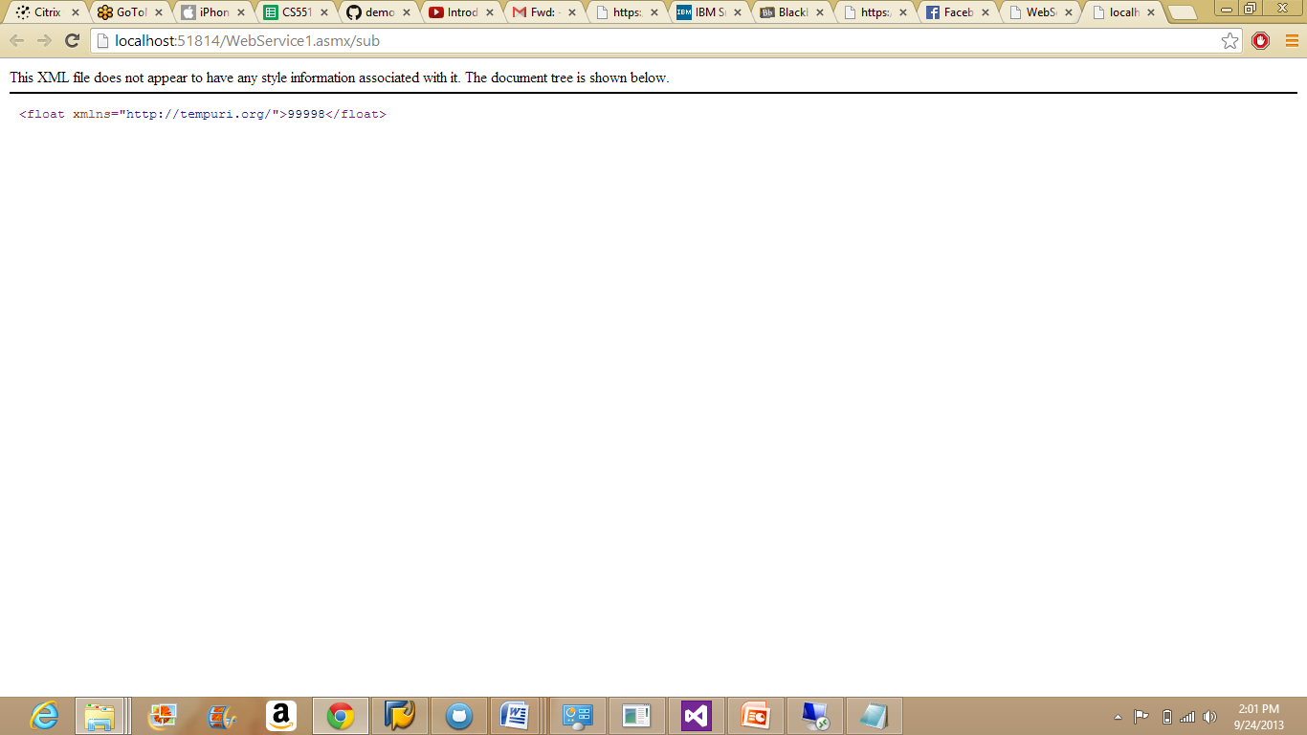

Copy the Soap Services created in the local copy and deploy the same code in the remote instance.

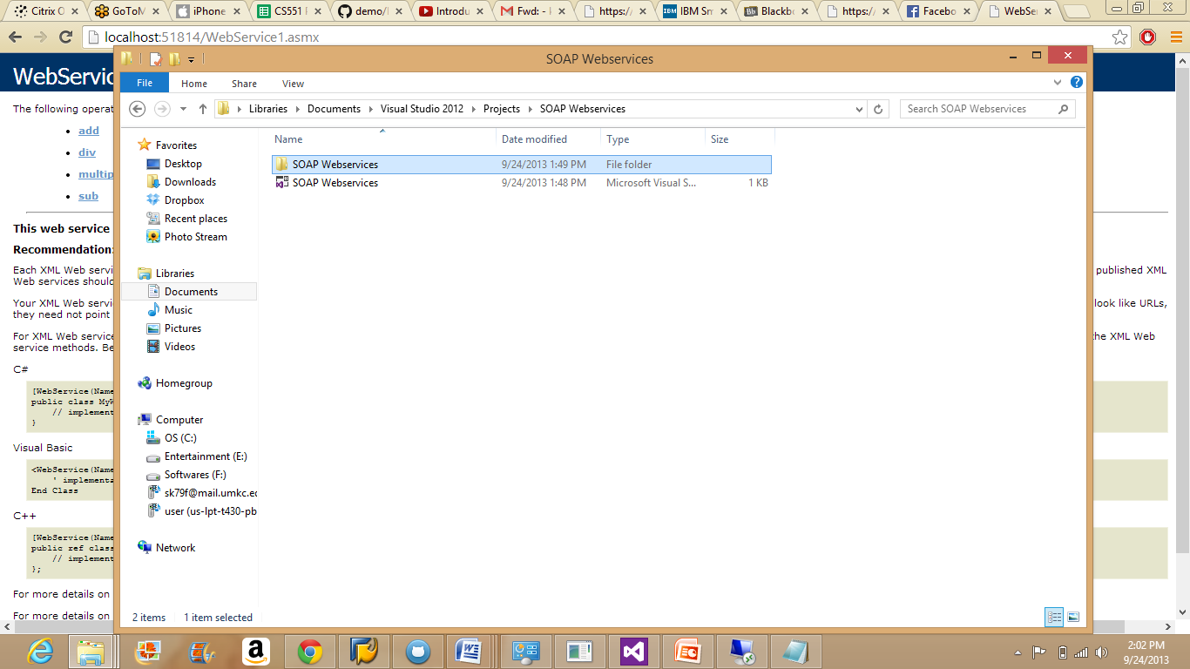

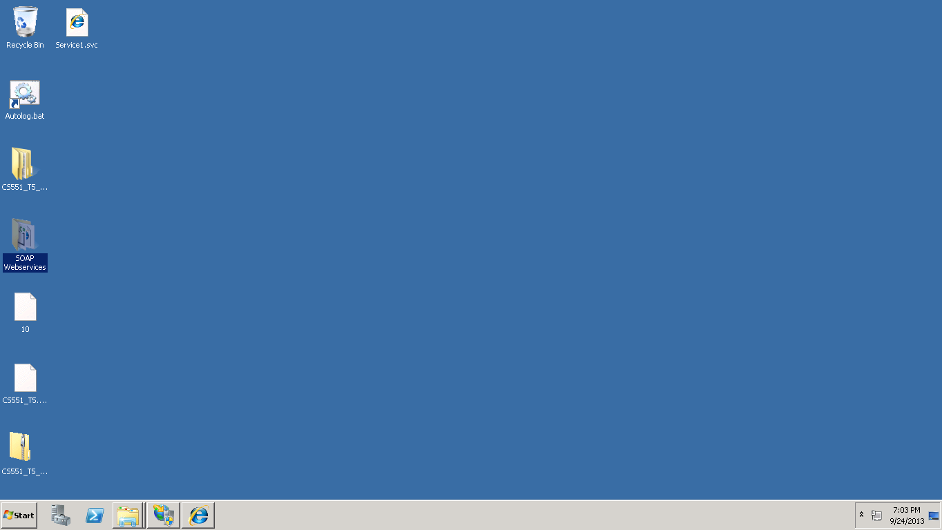

Go the IIS Manager and convert the SOAP service into an application.

